

**SHAID SMARAK COLLEGE**

Kirtipur, Kathmandu

*Assignment No. 2 of Microprocessor*

***Submitted by:-***

*Amir Maharjan*

*2nd Semester BCA*

***Submitted to:-***

*Himal Raj Gentil*

**Experiment No.1**

**OBJECTIVE:**

Write a program to add two hexadecimal numbers.

**Statement:**

add two number 05H and 13H and display result in output port 18H.

**Steps:**

* The MVI command moves the 05H and 13H to their respective destination A and B.
* Store the added number (new number) and display in the output port 18H.
* Terminate the program.

**Program: -**

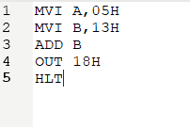

**Register: -**

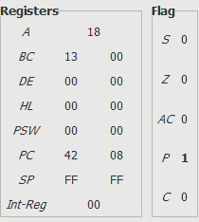

**Output port:-**

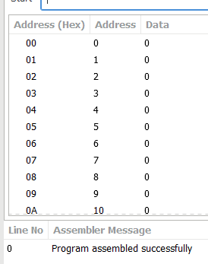

**Experiment No.2**

**Objective:**

Write a program to add two 8-bit hexadecimal numbers.

**Statement:**

Add numbers from memory location 2050H & 2051H and store result in memory location 2055H.

**Steps:**

* Load the data from the memory location 2051H
* Transfer the data
* Load to accumulator
* Store in 2055H memory location

**Program:**

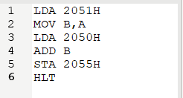

**Register:**

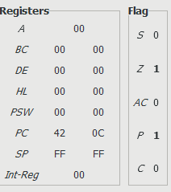

**Output port:**

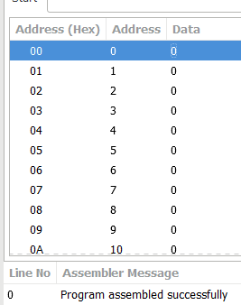

**Experiment No.3**

**Objective:**

Write a program to subtract two 8-bit hexadecimal numbers.

**Statement:**

Subtract numbers 25H & 12H and display result in output port o01H.

**Steps:**

* Transfer the data from memory location 25H and 12H respectively in A and B.
* Subtract
* Store the subtracted number (new number) in 01H port.

**Program:**

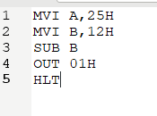

**Register:**

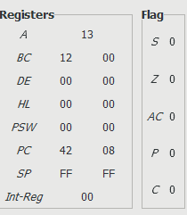

**Output port:**

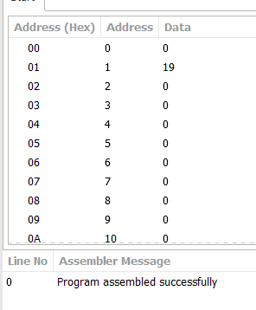

**Experiment No.4**

**Objective:**

Write a program to subtract two 8-bit numbers.

**Statement:**

Subtract numbers from memory location 2050H & 2051H and store result in memory location 2055H.

**Steps:**

* Same as Experiment 1 (only difference is the addition and subtraction).

**Program:**

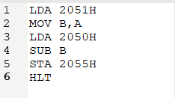

**Register:**

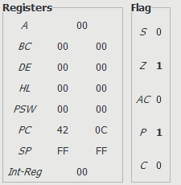

**Output port:**

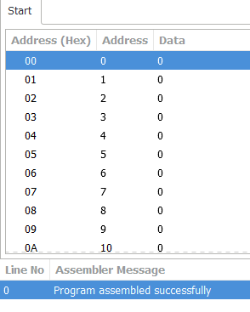

**Experiment No.5**

**Objective:**

Write a program to find 1’s complement of a number.

**Statement:**

Input number from memory location 2013H and store result in memory location 2055H.

**Steps:**

* Transfer data from memory location 2013H to Accumulator.
* Complement the contents in the accumulator.
* Store in 2052H memory location.

**Program:**

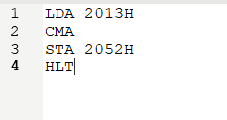

**Register:**

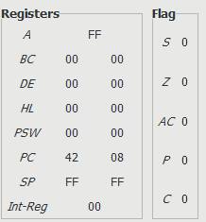

**Output port:**

